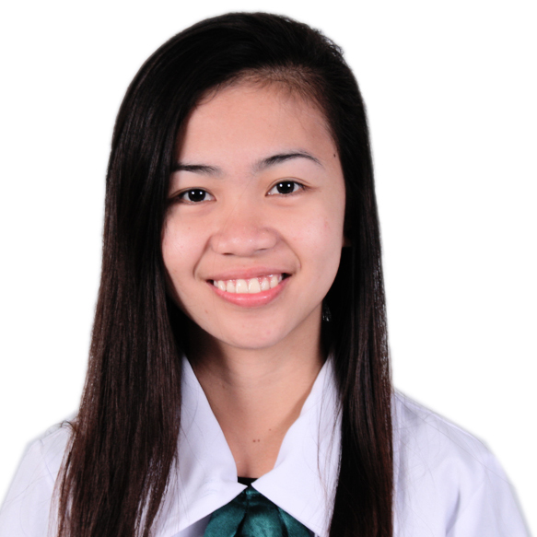

**Maria Jessah R. Villaban**

Current Address : **White Road Inayawan, Cebu City**

Email : [**mjvillaban@gmail.com**](mailto:mjvillaban@gmail.com)

Cell phone no : **+639434391621**

Tel no : **(032) 236-4871**

|  |
| --- |
| **Objective** |

* To be able to make myself accustomed to the IT Industry’s practices
* To enhance and expand my skills and experience in the IT field

|  |
| --- |
| **Education Background** |

***College:***

College Graduate (March 2014)

Bachelor of Science in Information Technology

Major in Web Application Development

University of San Jose-Recoletos

N. Bacalso Ave., Basak Pardo, Cebu City, Philippines

|  |
| --- |
| **Work Experience** |

**FREELANCE WEB DESIGNER**

November 2013 – Present

Was involved in

* Create PSD design for a responsive layered web pages
* Create PSD designs for a responsive Landing page

**OJT (Web Developer/ Web Designer)**

Globalsupport Business Solutions Inc. (BPO)

3/F Crown 7 IT Building, J. Luna Ave, 6000 Cebu City

January 2013 – May 2013

Was involved in

* Convert PSD to HTML and CSS
* Create and develop web based UI using HTML, CSS and PHP
* Create Web design Templates in PSD
* Create Business Card

**OJT (Data Entry)**

PLDT, Jones Avenue, Cebu City

September 2012 – December 2012

Was involved in

* Call outs
* Data Entry

|  |
| --- |
| **Portfolio** |

* <http://mjvillaban-portfolio.url.ph/>
* <http://webdevelopment-itproject.website.org/>
  + ACCESS
  + **Master Admin** (username: juan123) (password: iamaltair)
* **Assistant** (username: altemia) (password: iamaltair)

|  |
| --- |
| **Skills** |

* Basic Knowledge in PHP, Javascript, C, C#,
* Basic Knowledge in Web design , HTML and CSS
* Basic Knowledge in bootstrap , grid and codeigniter framework
* Basic Knowledge in Adobe Photoshop ,Illustrator and InDesign
* Typing speed of 68 wpm
* Knowledge in Microsoft word, Excel and PowerPoint

|  |
| --- |
| **Personal Information** |

Age : 20

Date of Birth : December 10,1993

Place of Birth : Saint Vincent Medical Hospital

Sex : Female

Civil Status : Single

Citizenship : Filipino

Religion : Roman Catholic

Language Used : Filipino, Cebuano, English

|  |
| --- |
| **Character References** |

**Mrs. Carmel Tejana**

IT Project Adviser

Faculty, CICCT Department

University of San Jose-Recoletos

Basak Pardo, Cebu City

(032) 417-9500 Local 122

**Ms. Marissa Mahilum**

IT Project Coordinator

Faculty, CICCT Department

University of San Jose-Recoletos

Basak Pardo, Cebu City

(032) 417-9500 Local 122

**Mrs. Ma. Lorna Miro**

IT Project Panel

Faculty, CICCT Department

University of San Jose-Recoletos

Basak Pardo, Cebu City

(032) 417-9500 Local 122